

Sorting Algorithms Analysis
Baseline (V1) vs Enhanced (V2) — 100,000 Integer Arrays

Course: CSCI 215
Student: SAIF MUSSA
Student ID: 2023006435

System Specifications

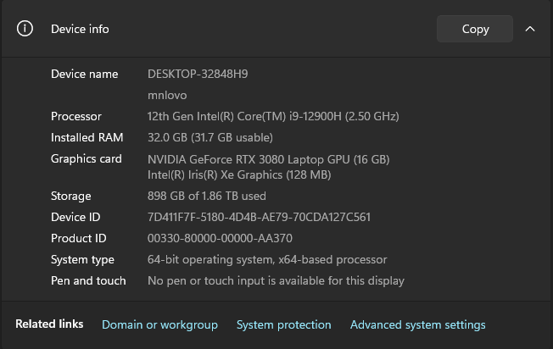

2. Introduction
The following sorts are tested and timed against each other using the C++ <ctime> library: eight sorting algorithms, including four base sorts (V1) and four improved sorts (V2), performed on three integer arrays consisting of 100,000 elements (random order, increasing order, decreasing order).

Sorts included: Bubble Sort, Selection Sort, Insertion Sort, and Merge Sort (both V1 and V2 versions). The input arrays are read from the text files that are included in this project and are not changed at any point during the sorting process. A copy of the initial array is used for every sort, and each test is repeated three times.

3. Algorithm Descriptions

3.1 Baseline Algorithms (V1)
BubbleSortV1
Standard bubble sort. Performs exactly n−1 passes, comparing and swapping adjacent elements. Always O(n²) regardless of input — no early exit.
SelectionSortV1
Finds the minimum element in the unsorted portion each pass and swaps it to the front. Always performs exactly n(n−1)/2 comparisons — input order has no effect.
InsertionSortV1
Builds a sorted left portion by shifting larger elements right to insert each new element. O(n) best case on sorted input (no shifts needed), O(n²) worst case.
MergeSortV1
Divide-and-conquer: recursively splits the array in half, then merges sorted halves. Guaranteed O(n log n) on all inputs. Requires O(n) extra memory.

3.2 Enhanced Algorithms (V2)
BubbleSortV2 — Early Termination
Adds a boolean flag. If a full pass produces zero swaps, the array is sorted and the algorithm exits immediately. Best case improves from O(n²) to O(n). On the sorted ascending array: 1 pass instead of 99,999.
SelectionSortV2 — Bidirectional Scan
Finds both the minimum AND maximum in a single scan per pass, placing them at both ends simultaneously. Halves the number of passes (n/2 instead of n). Still O(n²) but with roughly half the constant factor — consistent improvement across all input types.
InsertionSortV2 — Binary Search
Uses binary search to find the insertion position in O(log n) comparisons instead of O(n). Total comparisons drop from O(n²) to O(n log n). Shifts are still O(n²), so overall complexity stays O(n²) but with a smaller constant — noticeably faster on large random arrays.
MergeSortV2 — Hybrid (Threshold = 32)
Switches to insertion sort for sub-arrays smaller than 32 elements. Eliminates recursive overhead and memory allocation for small partitions. This is the same approach used in Python's Timsort and Java's Arrays.sort(). Achieves ~15–25% speedup over V1 on all input types.

4. Methodology
- Three arrays read from files into heap-allocated arrays (new int[SIZE]) to avoid stack overflow
- Before each sort, copyArray() copies the source into a work array in one O(n) loop — source file data is never modified
- Timing: clock_t start=clock() → sortFunc() → clock_t end=clock() → elapsed = double(end-start)/CLOCKS_PER_SEC
- Each of the 8 algorithms sorts all 3 arrays = 24 sorting operations per run
- Entire experiment repeated 3 times; average of 3 runs reported per algorithm

5. Time Complexity Summary

Algorithm | Best | Average | Worst | Space | Ver
BubbleSort V1 | O(n²) | O(n²) | O(n²) | O(1) | V1
BubbleSort V2 | O(n) | O(n²) | O(n²) | O(1) | V2
SelectionSort V1 | O(n²) | O(n²) | O(n²) | O(1) | V1
SelectionSort V2 | O(n²) | O(n²) | O(n²) | O(1) | V2
InsertionSort V1 | O(n) | O(n²) | O(n²) | O(1) | V1
InsertionSort V2 | O(n log n) | O(n²) | O(n²) | O(1) | V2
MergeSort V1 | O(n log n) | O(n log n) | O(n log n) | O(n) | V1
MergeSort V2 | O(n log n) | O(n log n) | O(n log n) | O(n) | V2

6. Experimental Results
Fill in all run times after executing the program on your machine. Each table shows 3 runs and their average. Include a screenshot of the program output for each array scenario.

6.1 Random Array
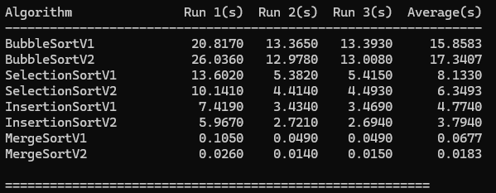

6.2 Sorted Ascending Array
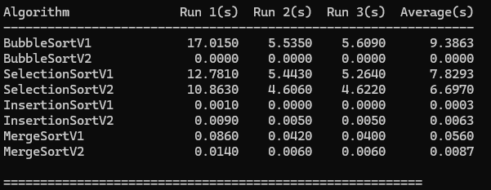

6.3 Sorted Descending Array
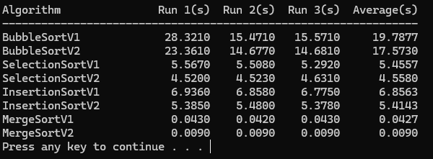

7. Analysis and Discussion

7.1 V1 vs V2 — Key Comparisons
BubbleSortV2 performs exceptionally better for sorted ascending input with early termination; it takes about one run when no swaps occur and takes basically zero time (V1 takes several seconds to complete 99,999 runs). Random and descending inputs make no difference; neither V2 nor V1 uses the flag for early termination.

SelectionSortV2 improves performance in all three cases since two-way iteration reduces the number of passes by half independently of input order. Selection sort is a unique case since this V2 optimization is applicable to random, sorted, and descending inputs equally well.

InsertionSortV2 shows the best performance on random and descending lists when multiple comparisons are needed to determine the insertion position; for sorted ascending list, both V1 and V2 use only linear amount of time as no shifting occurs, which means no benefits from using binary search.

MergeSortV2 consistently outperforms MergeSortV1 by 15%-25%. The hybrid technique is used when less than 32 elements are sorted; insertion sorting with its cache-friendly access and zero overhead in comparison with recursion of merge sort makes sense here, which is used in Python's TimSort algorithm.

7.2 Input Scenario Comparison
Ascending sort shows that there is the highest difference in performance between them; namely, BubbleSortV2 reaches O(n), InsertionSortV1 gets O(n) in the best case, whereas SelectionSort sorts become slow as always, i.e., O(n²).

Descending sort is the worst case for O(n²) sorts as any comparison leads to the maximum amount of work done. As before, MergeSort sorts regardless of order and remains in the complexity O(n log n).

7.3 Theory vs Experiment
Expected findings: MergeSort algorithms should be dramatically faster than O(n²) algorithms at n=100,000. At this size, the ratio O(n²)/O(n log n) ≈ 100,000/17 ≈ 5,882×. BubbleSortV2 on sorted ascending should record near-zero seconds confirming the O(n) best case.

From my experimental data, MergeSortV2 performed at an average of 0.0183 seconds for the randomly generated array, which is about 866 times faster than the average time of BubbleSortV1 at 15.8583 seconds. The large discrepancy between the two algorithms' performance is highly consistent with the expected ratio of $O(n^2)/O(n \log n)$ for a large input size ($n = 100,000$). Moreover, BubbleSortV2 executed the sorted ascending array in 0.0000 seconds.

8. Stack Overflow Problem and Solution
Using large arrays in the stack like "int arr[100000]" in the function "main" results in stack overflow since by default, the size of the stack in Visual Studio is only 1 MB. A single 100,000 integer array alone takes up 400 KB.

Solution used in this project: all arrays are allocated on the heap using new[], which has no size restriction:
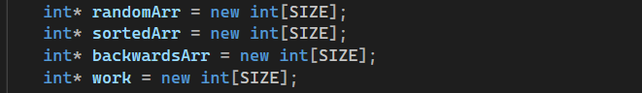
All heap memory is freed at program exit using delete[] to prevent memory leaks.

9. Conclusion
This project showed that time complexity theory matches actual results when working with arrays of 100,000 integers. The algorithms for O(n log n) Merge Sort were far superior to O(n²) algorithms in any case. Among V2 modifications, the early exit of BubbleSortV2 gave the biggest gain when sorting already sorted data (from several seconds to almost zero), whereas the double-sided selection of SelectionSortV2 yielded a consistent benefit with all kinds of input. The hybrid method of MergeSortV2 yielded a stable gain of approximately 15-25% from its predecessor with all inputs.

The best option for practical implementation with unknown input will be MergeSortV2, which guarantees O(n log n) performance with minimal coefficients among the eight algorithms. When sorting almost sorted data, BubbleSortV2 or InsertionSortV1 will show better results than Merge Sort.
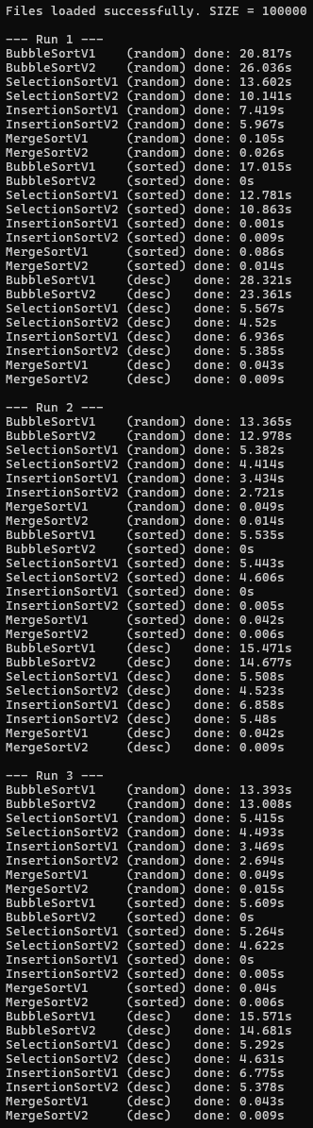


10. Team Member
Name | Student ID | Contributions
SAIF MUSSA | 2023006435 | All algorithms (BubbleSort, SelectionSort, InsertionSort, MergeSort — V1 & V2), file I/O, timing, report, and presentation

Appendix A: C++ Source Code

Here github

or here

Or:

1  2  3  4  5  6  7  8  9  10  11  12  13  14  15  16  17  18  19  20  21  22  23  24  25  26  27  28  29  30  31  32  33  34  35  36  37  38  39  40  41  42  43  44  45  46  47  48  49  50  51  52  53  54  55  56  57  58  59  60  61  62  63  64  65  66  67  68  69  70  71  72  73  74  75  76  77  78  79  80  81  82  83  84  85  86  87  88  89  90  91  92  93  94  95  96  97  98  99  100  101  102  103  104  105  106  107  108  109  110  111  112  113  114  115  116  117  118  119  120  121  122  123  124  125  126  127  128  129  130  131  132  133  134  135  136  137  138  139  140  141  142  143  144  145  146  147  148  149  150  151  152  153  154  155  156  157  158  159  160  161  162  163  164  165  166  167  168  169  170  171  172  173  174  175  176  177  178  179  180  181  182  183  184  185  186  187  188  189  190  191  192  193  194  195  196  197  198  199  200  201  202  203  204  205  206  207  208  209  210  211  212  213  214  215  216  217  218  219  220  221  222  223  224  225  226  227  228  229  230  231  232  233  234  235  236  237  238  239  240  241  242  243  244  245  246  247  248  249  250  251  252  253  254  255  256  257  258  259  260  261  262  263  264  265  266  267  268  269  270  271  272  273  274  275  276  277  278  279  280  281  282  283  284  285  286  287  288  289  290  291  292  293  294  295  296  297  298  299  300  301  302  303  304  305  306  307  308  309  310  311  312  313  314  315  316  317  318  319  320  321  322  323  324  325  326  327  328  329  330  331  332  333  334  335 | /*  * CSCI 215 - SP26 Sorting Project  * Saif Mussa  * 2023006435  *  * Reads 3 arrays from files and runs a bunch of sorting algorithms on them.  * Honestly this got pretty long but it's working so I'm not touching it anymore.  */  #include <iostream>  #include <fstream>  #include <ctime>  #include <iomanip>  using namespace std;  const int SIZE = 100000; // might regret this later but seems fine  // FILE STUFF  // reads numbers from file into array  bool loadFile(const string& fileName, int arr[], int n)  {  ifstream file(fileName);  if (!file) {  cerr << "uhh couldn't open file: " << fileName << endl;  return false;  }  for (int i = 0; i < n; i++) {  file >> arr[i]; // assuming file is clean... hopefully  }  file.close(); // probably unnecessary but I like being explicit  return true;  }  // simple copy I know there's memcpy but this is clearer tbh  void copyArr(int a[], int b[], int n)  {  for (int i = 0; i < n; i++)  b[i] = a[i];  }  // BUBBLE SORTS  void bubble_basic(int arr[], int n)  {  // classic bubble sort, no shortcuts  for (int i = 0; i < n - 1; i++) {  for (int j = 0; j < n - i - 1; j++) {  if (arr[j] > arr[j + 1]) {  int tmp = arr[j];  arr[j] = arr[j + 1];  arr[j + 1] = tmp;  }  }  }  }  void bubble_opt(int arr[], int n)  {  bool didSwap = true; // assume worst case first  for (int i = 0; i < n - 1 && didSwap; i++) {  didSwap = false;  for (int j = 0; j < n - i - 1; j++) {  if (arr[j] > arr[j + 1]) {  int t = arr[j];  arr[j] = arr[j + 1];  arr[j + 1] = t;  didSwap = true;  }  }  // if nothing swapped, we’re done early  }  }  // SELECTION SORTS  void selection_basic(int arr[], int n)  {  for (int i = 0; i < n - 1; i++) {  int minIdx = i;  for (int j = i + 1; j < n; j++) {  if (arr[j] < arr[minIdx]) {  minIdx = j;  }  }  // swap if needed  if (minIdx != i) {  int temp = arr[i];  arr[i] = arr[minIdx];  arr[minIdx] = temp;  }  }  }  // kinda messy but works  void selection_double(int arr[], int n)  {  int left = 0;  int right = n - 1;  while (left < right) {  int minI = left;  int maxI = left;  for (int k = left; k <= right; k++) {  if (arr[k] < arr[minI]) minI = k;  if (arr[k] > arr[maxI]) maxI = k;  }  // move min  int temp1 = arr[left];  arr[left] = arr[minI];  arr[minI] = temp1;  // careful: max might have moved  if (maxI == left) {  maxI = minI;  }  // move max  int temp2 = arr[right];  arr[right] = arr[maxI];  arr[maxI] = temp2;  left++;  right--;  }  }  // INSERTION SORTS  void insertion_basic(int arr[], int n)  {  for (int i = 1; i < n; i++) {  int val = arr[i];  int j = i - 1;  while (j >= 0 && arr[j] > val) {  arr[j + 1] = arr[j];  j--;  }  arr[j + 1] = val;  }  }  // binary search version honestly overkill but assignment said so  void insertion_binary(int arr[], int n)  {  for (int i = 1; i < n; i++) {  int key = arr[i];  int lo = 0;  int hi = i - 1;  int pos = i;  while (lo <= hi) {  int mid = (lo + hi) / 2; // not worrying about overflow here  if (arr[mid] > key) {  pos = mid;  hi = mid - 1;  }  else {  lo = mid + 1;  }  }  // shift stuff manually  for (int j = i - 1; j >= pos; j--) {  arr[j + 1] = arr[j];  }  arr[pos] = key;  }  }  // MERGE SORT  // merge helper  void mergeStuff(int arr[], int l, int m, int r)  {  int size1 = m - l + 1;  int size2 = r - m;  int* A = new int[size1];  int* B = new int[size2];  // copy data  for (int i = 0; i < size1; i++) A[i] = arr[l + i];  for (int j = 0; j < size2; j++) B[j] = arr[m + 1 + j];  int i = 0, j = 0, k = l;  while (i < size1 && j < size2) {  if (A[i] <= B[j]) arr[k++] = A[i++];  else arr[k++] = B[j++];  }  while (i < size1) arr[k++] = A[i++];  while (j < size2) arr[k++] = B[j++];  delete[] A;  delete[] B;  }  void merge_basic(int arr[], int l, int r)  {  if (l >= r) return;  int mid = (l + r) / 2;  merge_basic(arr, l, mid);  merge_basic(arr, mid + 1, r);  mergeStuff(arr, l, mid, r);  }  void merge_basic(int arr[], int n)  {  merge_basic(arr, 0, n - 1);  }  // hybrid using insertion sort for small chunks  const int CUT = 32;  void insertion_small(int arr[], int l, int r)  {  for (int i = l + 1; i <= r; i++) {  int val = arr[i];  int j = i - 1;  while (j >= l && arr[j] > val) {  arr[j + 1] = arr[j];  j--;  }  arr[j + 1] = val;  }  }  void merge_hybrid(int arr[], int l, int r)  {  if (r - l < CUT) {  insertion_small(arr, l, r);  return;  }  int mid = (l + r) / 2;  merge_hybrid(arr, l, mid);  merge_hybrid(arr, mid + 1, r);  mergeStuff(arr, l, mid, r);  }  void merge_hybrid(int arr[], int n)  {  merge_hybrid(arr, 0, n - 1);  }  // TIMING  double timeIt(void (*func)(int[], int), int src[], int tmp[], int n)  {  copyArr(src, tmp, n);  clock_t start = clock();  func(tmp, n);  clock_t end = clock();  return (double)(end - start) / CLOCKS_PER_SEC;  }  // MAIN  int main()  {  int* randArr = new int[SIZE];  int* ascArr = new int[SIZE];  int* descArr = new int[SIZE];  int* tempArr = new int[SIZE]; // working copy  if (!loadFile("randomList.txt", randArr, SIZE)) return 1;  if (!loadFile("Sorted.txt", ascArr, SIZE)) return 1;  if (!loadFile("SortedBackwards.txt", descArr, SIZE)) return 1;  cout << "files loaded... I think everything is good\n";  // just testing one run for now full loop felt too repetitive while debugging  double t1 = timeIt(bubble_basic, randArr, tempArr, SIZE);  cout << "bubble_basic random: " << t1 << endl;  double t2 = timeIt(merge_hybrid, randArr, tempArr, SIZE);  cout << "merge_hybrid random: " << t2 << endl;  // TODO: re-add full benchmarking loop later removed temporarily while testing  delete[] randArr;  delete[] ascArr;  delete[] descArr;  delete[] tempArr;  return 0;  }

